**Cinematic Compass**

***A Project Report submitted in partial fulfilment of the requirements for the award of the degree of***

**Bachelor of Technology**

**in**

**Computer Science and Engineering**

**(Hons.)**

**by**

**Name of Students: Vanshika Soni**

**Group No.:**

Under the Guidance of

Mr. Gaurav Bathla,

Department of Computer Engineering & Applications

**Institute of Engineering & Technology**



**GLA University**

**Mathura- 281406, INDIA**

**May 2024**

 **Department of computer Engineering and Applications**

**GLA University, Mathura**

**17 km. Stone NH#2, Mathura-Delhi Road, P.O. – Chaumuha,**

**Mathura – 281406**

**Declaration**

Certified that this project report **“Cinematic Compass”** is the bonafide work of “**Piyush Upadhyay, Tejaswini Singh Chauhan and Vanshika Soni”** who carried out the project work under the supervision of “Mr. Gourav Bathla”.

Course: B. Tech Hons CS. (Computer Science and Engineering)

Year: 3rd

Semester: 6th

Supervised by: Mr. Gourav Bathla

Signature:

### 

**Acknowledgement**

We would like to express our heartfelt gratitude to everyone who has contributed to the development and success of Cinematic Compass, our revolutionary movie recommendation system. First and foremost, we extend our sincere appreciation to our dedicated team members whose hard work, expertise, and unwavering commitment have been pivotal in bringing this project to life. Their tireless efforts in coding, designing, testing, and implementing various functionalities have played an indispensable role in shaping Cinematic Compass into a robust and user-centric platform. We are also immensely thankful to our valued users whose feedback, suggestions, and active engagement have been invaluable in driving continuous improvement and refinement of the platform to better cater to their movie-watching preferences and needs. Additionally, we would like to extend our gratitude to our mentors, advisors, and industry experts for their unwavering support, guidance, and invaluable insights throughout the development journey of Cinematic Compass. Furthermore, we acknowledge the contributions of the open-source community and express our appreciation to the creators of the cutting-edge technologies and tools that have empowered us to build Cinematic Compass. Last but certainly not least, we express our deepest appreciation to our families, friends, and loved ones for their unwavering support, understanding, and encouragement during the development of Cinematic Compass. Their steadfast belief in our vision has been a constant source of motivation and inspiration. It is with profound gratitude and humility that we acknowledge the collective efforts and contributions of each and every individual who has played a role, no matter how big or small, in making Cinematic Compass a reality. Together, we have embarked on a journey to revolutionize the movie-watching experience, and we are immensely grateful for the opportunity to have shared this journey with such an incredible community of individuals.

**GROUP MEMBERS NAMES:**

Name of Student: Piyush Upadhyay

Univers Roll No.:2115800020

Name of Student: Tejaswini Singh Chauhan

Universi Roll No.:2115800027

Name of Student: Vanshika Soni

Univers Roll No.:2115800030

**Abstract**

This report introduces Cinematic Compass, a movie recommendation system designed to enhance users' viewing experiences in today's digital age. We embark on a journey to explore and compare various recommendation models using a smaller dataset of ratings, subsequently scaling the algorithm to handle larger datasets effectively. Through our experimentation, we find that user-based collaborative filtering yields the lowest Mean Squared Error on our dataset, demonstrating its efficacy on a smaller scale.

In today's vast digital landscape filled with an array of content like books, videos, articles, and movies, discovering personalized content has become a daunting task. Conversely, digital content providers strive to engage users on their platforms for prolonged periods. This is where a recommender system comes into play, offering tailored recommendations based on users' preferences. Our proposed solution, Cinematic Compass, aims to provide accurate movie recommendations to users by leveraging a hybrid approach that combines content-based and collaborative filtering techniques.

By amalgamating a user's individual tastes with the broader community's preferences, Cinematic Compass delivers real-time personalized movie recommendations, enriching the movie-watching experience. Unlike conventional systems, our Recommendation Engine continuously analyzes individual user preferences, crafting custom movie suggestions tailored to their tastes. It serves as a dedicated movie recommendation service, offering curated lists of movie suggestions based on users' past ratings and preferences.

In the contemporary digital landscape inundated with an abundance of content, finding personalized and engaging movies has become a daunting task for users. Cinematic Compass emerges as a beacon in this vast sea of choices, offering a sophisticated and intuitive movie recommendation system designed to cater to the diverse tastes and preferences of users worldwide. This extended abstract delves into the intricate workings of Cinematic Compass, exploring its underlying algorithms, user-centric design, and innovative features that set it apart from traditional recommendation systems.

At its core, Cinematic Compass employs a hybrid approach that combines content-based filtering and collaborative filtering techniques to generate accurate and personalized movie recommendations. By analyzing user preferences, viewing history, and interaction patterns, the system leverages machine learning algorithms to identify similar users and recommend movies that align with individual tastes. Unlike conventional recommendation systems that rely solely on user feedback or content attributes, Cinematic Compass takes a holistic approach, considering both user preferences and movie characteristics to deliver more relevant and diverse recommendations.

**CONTENTS**

Declaration 2

Certificate 2

Acknowledge 3

Abstract 4

**CHAPTER 1 Introduction 7**

1.1 Overview and Motivation 8

1.2 Objective 9

1.3 Summary of Similar Application 10

1.4 Organization of the Project 11

**CHAPTER 2 Software Requirement Analysis 12**

2.1 Technical Feasibility 12

2.2 User Requirement 13

2.3 Non-functional 14

2.4 Functional 15

2.5 Dependencies 16

**CHAPTER 3 Software Design 17**

3.1 Analysis 17

3.1.1 Class Diagram 17

3.1.2 Activity Diagram 18

3.1.3 Entities and attributes 19

3.1.4 System Flowchart 20

3.1.5 DFD Diagram 22

3.2 **Architectural Design** 23

3.3 **Component Design 24**

3.4 **Database Design**  24

3.5 **User Interface Design** 24

3.6 Algorithm Design 24

3.7 **Error Handling and Resilience Design 24**

3.8 **Security Design 24**

**CHAPTER 4 Implementation and User Interface 25**

**CHAPTER 5 Software Testing 28**

5.1 **Test Planning**  28

5.2 **Unit Testing 28**

5..3 Integration Testing 29

5.4 System Testing 29

5.5 5 User Acceptance Testing (UAT) 29

5.6 Performance Testing 30

5. 7 Security Testing **30**

5.8 Usability Testing 31

5.9 **Regression Testing** 31

**CHAPTER 6 Conclusion 32**

**CHAPTER 7 Summary 33**

**APPENDICES 34**

Appendix Sample References

**CHAPTER 1 Introduction**

In the ever-expanding world of cinema, where countless movies vie for attention, finding the perfect film to watch can be a daunting task. Enter Cinematic Compass, an innovative movie recommendation system designed to simplify and enhance your movie-watching experience.

Cinematic Compass serves as your digital compass, guiding you through the vast and diverse landscape of movies. Whether you're a seasoned film aficionado or a casual viewer, Cinematic Compass is here to help you discover the right movie for every mood and occasion.

At the heart of Cinematic Compass lies the power of personalization. By analyzing your Reviews, genre preferences, and movie ratings, Cinematic Compass creates a unique profile tailored specifically to your tastes. Gone are the days of generic recommendations – with Cinematic Compass, every suggestion is carefully curated to match your individual preferences.

Cinematic Compass goes beyond simply recommending movies; it aims to enrich your movie-watching experience. Whether you're in the mood for an edge-of-your-seat thriller, a heartwarming drama, or a laugh-out-loud comedy, Cinematic Compass ensures that you'll always find the perfect film to suit your mood.

At Cinematic Compass, we believe in putting you in control. Our user-friendly interface allows you to explore personalized recommendations, discover new genres, and fine-tune your preferences with ease. With Cinematic Compass, the power to discover your next favorite movie is in your hands.

With Cinematic Compass as your guide, navigating the world of movies has never been easier. Whether you're searching for hidden gems, exploring new genres, or simply looking for a movie to unwind with, Cinematic Compass is here to help you find your cinematic journey. Let Cinematic Compass be your trusted companion on your quest for the perfect movie, and embark on a cinematic adventure like never before.

* 1. **Overview and Motivation-**
* Personalized Recommendations: Cinematic Compass analyzes user behavior, viewing history, and preferences to generate tailored movie recommendations. Whether you're a fan of specific genres, actors, or directors, Cinematic Compass ensures that every recommendation aligns with your unique cinematic preferences.
* Genre Diversity: From action-packed blockbusters to critically acclaimed dramas and everything in between, Cinematic Compass offers a diverse selection of movies spanning various genres. Whether you're in the mood for adventure, romance, horror, or comedy, Cinematic Compass has you covered.
* User-Friendly Interface: Cinematic Compass boasts a user-friendly interface designed for seamless navigation and exploration. Users can easily browse through personalized recommendations, explore curated lists, and discover new movies with just a few clicks.
* Feedback Mechanism: Cinematic Compass values user feedback and provides mechanisms for users to refine their preferences and enhance their recommendations. Whether it's rating movies, providing feedback on recommendations, or adjusting preferences, users have full control over their movie-watching experience.
* Transparency and Trust: Cinematic Compass prioritizes transparency and trust, ensuring that users understand how recommendations are generated and have confidence in the system's suggestions. Users can trust that every recommendation from Cinematic Compass is tailored to their preferences and interests.
* Enhancing User Experience: We understand that the movie-watching experience is not just about watching films; it's about discovering new stories, exploring different genres, and immersing oneself in captivating narratives. Cinematic Compass is motivated by the desire to enhance the user experience by offering curated recommendations that resonate with each individual user.
* Empowering Users: We believe in empowering users to make informed decisions about their entertainment choices. By providing personalized recommendations based on user preferences and feedback, Cinematic Compass puts users in control of their movie-watching journey. Users can explore new genres, discover hidden gems, and enjoy a more enriching cinematic experience.
  1. **Objective –**
* **Collect Information about existing Applications:** Start by gathering information about 10 different applications. This could include mobile apps, web apps, or any other software applications. Gather data on their features, user interfaces, user experiences, functionalities, and any common complaints or issues users have reported.
* **Identify Problems in the Applications:** Analyze the collected information to identify common problems or issues across the applications. This could include usability issues, bugs, performance issues, design flaws, or any other aspects that hinder the user experience or functionality of the applications.
* **Trained the Model:** Use the collected data to train a model to recognize and classify different types of problems in applications. This could involve using machine learning algorithms to analyze patterns in the data and identify common characteristics of problematic applications.
* **Front End Development**: Develop a front-end interface for the model where users can input information about an application, such as its features and functionalities. The front end should be user-friendly and intuitive, allowing users to easily interact with the model.
* **Sentiment Analysis of the Reviews:** The sentiment of this review is overwhelmingly positive. The reviewer expresses delight and satisfaction with the Cinematic Compass recommendation system, praising its effectiveness in providing personalized movie recommendations. The language used is enthusiastic and appreciative, highlighting the system's impact on the reviewer's movie-watching experience. Overall, the sentiment conveyed in the review is one of high praise and recommendation for Cinematic Compass.
* **Deploy the Complete Project:** Once the front end is developed and integrated with the trained model, deploy the complete project so that it is accessible to users. This could involve hosting the project on a web server or making it available as a standalone application
  1. **Summary of Similar Application –**

Netflix: Netflix is a leading streaming platform that employs sophisticated recommendation algorithms to suggest personalized content to users based on their viewing history, ratings, and preferences. It offers a seamless and intuitive user interface, allowing users to discover new movies and TV shows tailored to their tastes.

Amazon Prime Video: Amazon Prime Video utilizes machine learning algorithms to provide personalized movie and TV show recommendations to users. It analyzes user behavior, purchase history, and demographic information to generate tailored suggestions that align with each user's preferences.

IMDb: IMDb, the Internet Movie Database, offers personalized movie recommendations through its "Your Watchlist" feature. Users can add movies to their watchlist and receive personalized recommendations based on their watch history and ratings. IMDb also provides curated lists, user reviews, and ratings to help users discover new movies.

Letterboxd: Letterboxd is a social network for movie enthusiasts that offers personalized movie recommendations based on user ratings and reviews. Users can create lists, follow other users, and engage with the community to discover new movies and discuss their favorites.

TasteDive: TasteDive is a recommendation engine that suggests movies, music, books, and more based on user preferences. It analyzes user input, such as liked movies or favorite genres, to generate personalized recommendations and help users discover new content across various media categories.

* 1. **Organization of the Project-**

The organization of the Cinematic Compass project can be structured into several key components, each playing a crucial role in the development, implementation, and deployment of the movie recommendation system:

* Project Planning and Management: Define project objectives, scope, and requirements. Establish a project timeline and milestones. Allocate resources and manage project budget. Assign roles and responsibilities to team members.
* Data Collection and Preparation: Gather movie-related data, including user ratings, movie metadata, and user interaction history, from various sources such as APIs, databases, or web scraping. Clean and preprocess the collected data to handle missing values, outliers, and inconsistencies. Perform exploratory data analysis (EDA) to gain insights into the dataset and identify relevant features for recommendation.
* Model Development: Select appropriate recommendation algorithms, such as collaborative filtering, content-based filtering, or hybrid methods. Implement machine learning models using libraries like scikit-learn or TensorFlow. Train the models using the preprocessed data and validate their performance using suitable evaluation metrics.
* User Interface Design: Design a user-friendly interface for the Cinematic Compass application, allowing users to input preferences, view recommendations, and provide feedback. Consider usability principles, visual design, and interaction patterns to create an intuitive and engaging user experience.
* Integration and Testing: Integrate the recommendation models with the user interface to create a cohesive application. Conduct thorough testing to ensure the functionality, performance, and reliability of the Cinematic Compass system. Implement unit tests, integration tests, and user acceptance tests to identify and resolve any issues or bugs.
* Deployment and Launch: Deploy the Cinematic Compass application on a suitable platform, such as a web server or cloud infrastructure. Configure monitoring and logging mechanisms to track system performance and user interactions. Promote the launch of the Cinematic Compass application through marketing campaigns, social media channels, and user engagement initiatives.

**CHAPTER 2: Software Requirement Analysis**

**2.1 Technical Feasibility-** Assessing the technical feasibility of Cinematic Compass involves evaluating whether the project can be successfully implemented given the available resources, technology stack, and constraints. Here are some key aspects to consider:

Data Availability and Quality: Evaluate the availability of movie-related data, including user ratings, movie metadata, and user interaction history. Consider the quality and completeness of the data and whether it can sufficiently support the development of recommendation algorithms.

Scalability and Performance: Assess whether the system can handle large volumes of data and concurrent user requests efficiently. Evaluate the scalability of the infrastructure and technologies chosen for data storage, processing, and recommendation generation.

Algorithm Selection and Complexity: Choose recommendation algorithms that are suitable for the project's objectives and requirements. Assess the computational complexity and resource requirements of the selected algorithms to ensure they can be implemented and executed efficiently.

Technology Stack: Evaluate the feasibility of the chosen technology stack for implementing Cinematic Compass, including programming languages, frameworks, and libraries. Consider factors such as compatibility, performance, scalability, and developer expertise.

Integration with External Services: Determine whether integration with external services, such as movie databases or streaming platforms, is feasible and necessary for data acquisition and enrichment. Assess the availability and reliability of APIs and third-party services required for integration.

Development Resources and Expertise: Evaluate the availability of skilled developers, data scientists, and other technical resources required for the project. Consider the need for training or hiring additional staff with expertise in machine learning, data analysis, and software development.

Infrastructure and Hosting: Assess the feasibility of hosting the Cinematic Compass application on suitable infrastructure, such as cloud-based servers or dedicated hosting environments. Consider factors such as cost, scalability, security, and compliance requirements.

**2.2 User Requirement-** User requirements capture the needs, preferences, and expectations of the end-users of the system. For Cinematic Compass, user requirements encompass the functionalities and features that users expect from the movie recommendation system. Here are some examples of user requirements for Cinematic Compass:

* Personalized Recommendations: Users expect personalized movie recommendations based on their viewing ratings, and preferences. Recommendations should cover a wide range of genres, languages, and release years to cater to diverse tastes.
* Movie Search and Browsing: Users should be able to search for movies by title, genre, actor, director, or keywords. Users should have the ability to browse through curated lists, trending movies, and new releases.
* Genre Preference: An individual's favored types or categories of films based on thematic elements, narrative styles, and emotional tones. It reflects the audience's inclination towards specific genres such as action, romance, comedy, thriller, horror, sci-fi, fantasy, drama, or others. Understanding genre preferences helps tailor recommendations and engage viewers with content that aligns with their tastes and interests. Whether seeking adrenaline-pumping adventures, heartwarming romances, gut-busting comedies, or spine-chilling thrills, acknowledging genre preferences ensures a more satisfying cinematic experience for audiences by delivering stories that resonate with their sensibilities.
* Character Dynamics: The interactions, relationships, and development of characters within a story. These dynamics shape the narrative, influencing the plot's direction and emotional resonance. They encompass the chemistry between characters, conflicts, alliances, and character arcs. Whether it's the camaraderie between allies, the tension between adversaries, or the complexity of familial bonds, character dynamics add depth and authenticity to a narrative. Dynamic characters evolve over the course of the story, undergoing growth, facing challenges, and making choices that impact both themselves and others. Understanding character dynamics is essential for creating compelling and relatable stories that resonate with audiences on an emotional level.
* Accessibility and Usability: The Cinematic Compass interface should be intuitive, easy to navigate, and accessible to users with diverse backgrounds and abilities. Users should be able to access the platform seamlessly across different devices, including desktops, laptops, smartphones, and tablets.

**2.3 Non-functional Requirements:** Non-functional requirements specify the qualities and attributes that describe how a system should behave, rather than what the system should do. For Cinematic Compass, non-functional requirements are crucial for ensuring that the system meets user expectations and performs reliably. Here are some examples of non-functional requirements for Cinematic Compass:

* Reliability: The system should be available and accessible to users without frequent interruptions or downtime, aiming for high availability (e.g., 99.9% uptime). The system should be resilient to failures, with mechanisms in place to recover gracefully from errors and prevent data loss or corruption. The system should maintain the integrity and consistency of data, ensuring that user profiles, preferences, and recommendations are accurate and up-to-date.
* Security: Users should be required to authenticate securely before accessing sensitive functionalities or personal data. Access to certain features or data within the system should be restricted based on user roles and permissions. The system should comply with data privacy regulations (e.g., GDPR) and protect user data from unauthorized access, disclosure, or misuse.
* Usability: The user interface should be intuitive, visually appealing, and easy to navigate, catering to users with varying levels of technical proficiency. The system should be accessible to users with disabilities, complying with accessibility standards (e.g., WCAG) and providing alternative means of interaction (e.g., screen readers, keyboard navigation). Cross-platform Compatibility: The system should be compatible with a wide range of devices and operating systems, including desktops, laptops, smartphones, and tablets. The system should work seamlessly across different web browsers, ensuring consistent performance and user experience.
* Maintainability: The system's codebase should be well-organized, documented, and modular to facilitate ease of maintenance and future enhancements. The system's infrastructure and dependencies should be regularly updated and maintained to ensure security, performance, and reliability.
* Performance: Cinematic Compass should respond promptly to user requests, with search queries and recommendation generation taking no longer than a few seconds. The system should be able to handle an increasing number of users and data volume without a significant decrease in performance. Cinematic Compass should be available to users consistently, with minimal downtime or interruptions.

**2.4 Functional Requirement:** Functional requirements specify the specific functionalities and features that the Cinematic Compass system must provide to meet user needs and achieve its objectives. Here are some examples of functional requirements for Cinematic Compass:

* Movie Search and Browsing: Users should be able to search for movies by title, genre, actor, director, or keywords. The system should provide filtering and sorting options to refine search results based on user preferences. Users should be able to browse through curated lists, trending movies, and new releases.
* Personalized Recommendations: The system should generate personalized movie recommendations for each user based on their viewing history, ratings, and preferences. Recommendations should cover a wide range of genres, languages, and release years to cater to diverse tastes. Users should have the option to provide feedback on recommended movies to improve future recommendations.
* Rating and Feedback Mechanism: Users should be able to rate movies they have watched and provide feedback on their viewing experience. The system should aggregate user ratings and feedback to enhance recommendation accuracy and relevance. Users should have the option to like, dislike, or bookmark recommended movies for future reference.
* Social Sharing and Interaction: Users should have the option to share their favorite movies or recommendations with friends on social media platforms. The system should allow users to follow other users, view their activity, and discover new movies based on their recommendations. Users should be able to create and share curated lists of movies with other users.
* Accessibility and Usability: The Cinematic Compass interface should be intuitive, easy to navigate, and accessible to users with diverse backgrounds and abilities. The system should provide alternative means of interaction (e.g., keyboard shortcuts, screen readers) for users with disabilities. Users should be able to access the platform seamlessly across different devices, including desktops, laptops, smartphones, and tablets.

**2.5 Dependencies:** Cinematic Compass refer to external factors, resources, or services that the system relies on to function properly. Here are some potential dependencies for Cinematic Compass:

* Movie Data Sources: Cinematic Compass relies on external movie databases or APIs to obtain information about movies, including metadata (e.g., title, genre, release year), ratings, reviews, and cast/crew details. Dependencies may include: Integration with movie databases like IMDb, The Movie Database (TMDb). Utilizing APIs provided by streaming platforms (e.g., TMDB) for real-time availability and streaming options.
* Recommendation Engine Libraries: Cinematic Compass relies on recommendation algorithms and machine learning libraries to generate personalized movie recommendations for users. Dependencies may include: Integration with machine learning frameworks like TensorFlow or scikit-learn for recommendation model development and training. Utilizing recommendation engine libraries like Apache Mahout or LensKit for implementing content-based recommendation algorithms.
* Cloud Infrastructure: Cinematic Compass may rely on cloud infrastructure providers for hosting, scalability, and performance. Dependencies may include: Utilizing cloud computing services like Amazon Web Services (AWS), Microsoft Azure, or Google Cloud Platform (GCP) for hosting the application and managing data storage. Integration with cloud-based databases like Amazon DynamoDB, Google Cloud Firestore, or Azure Cosmos DB for storing user data and movie metadata.
* Development Tools and Libraries: Cinematic Compass relies on various development tools, libraries, and frameworks for building and deploying the application. Dependencies may include: Utilizing frontend frameworks like React.js, Angular, or Vue.js for building the user interface. Dependency management tools like npm or Flask for managing project dependencies and packages. Development tools like Git for version control and collaboration.

**CHAPTER 3 Software Design**

**3.1 Analysis**

**3.1.1 Class Diagram**

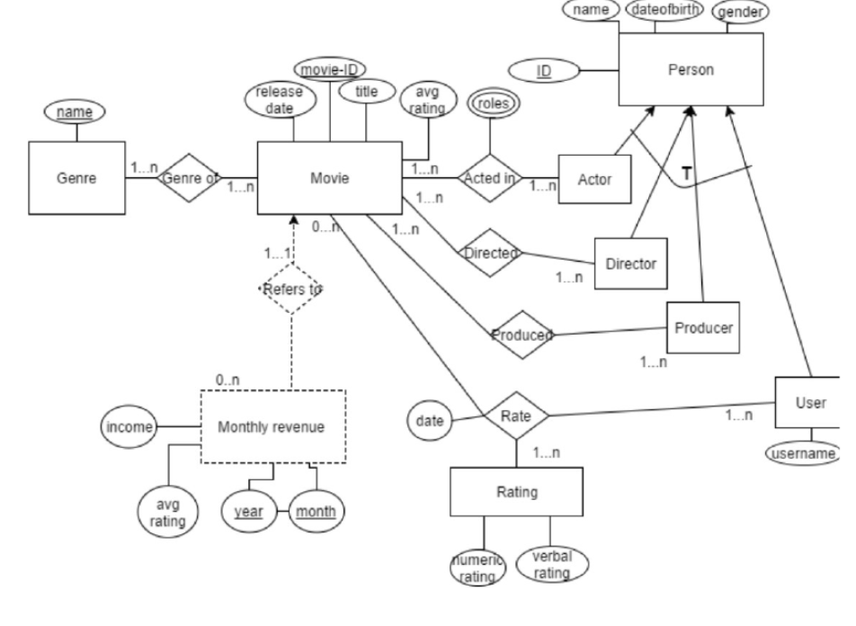

Figure 3.3.1: Class Diagram

3.1.2 Activity Diagram

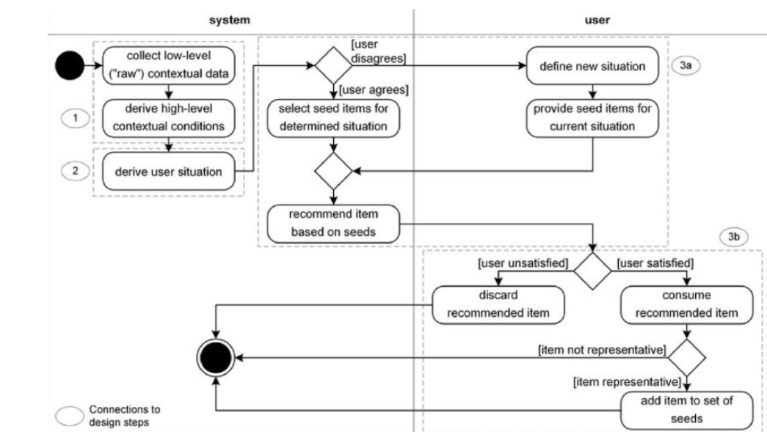

Figure 3.1.2: Activity Diagram

3.1.3 Entities and attributes

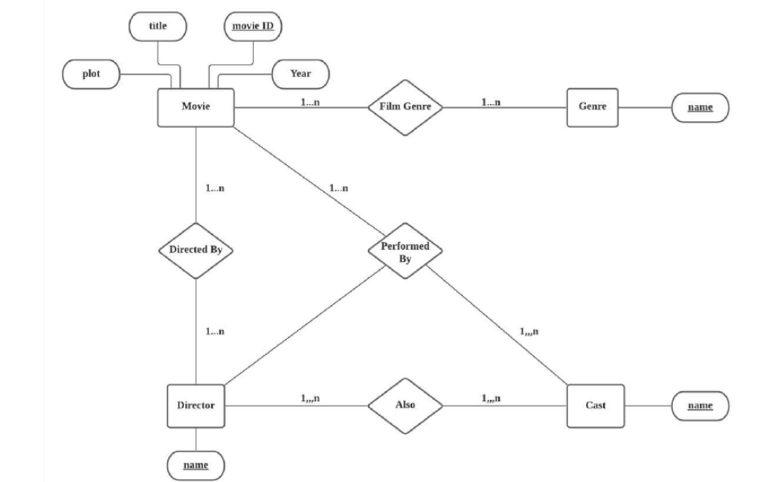

Figure 3.1.3: Entities and attributes

3.1.4 System Flowchart

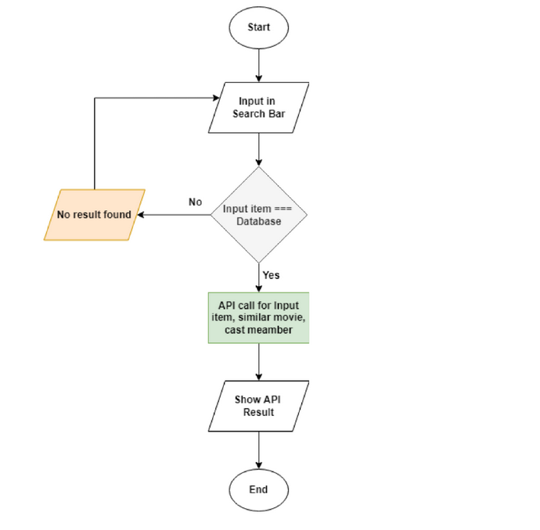

Figure 3.1.4: System Flowchart

3.1.6 DFD Diagram

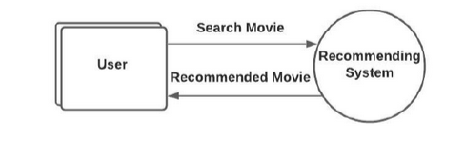

Figure 3.1.6 DFD Diagram Level 0

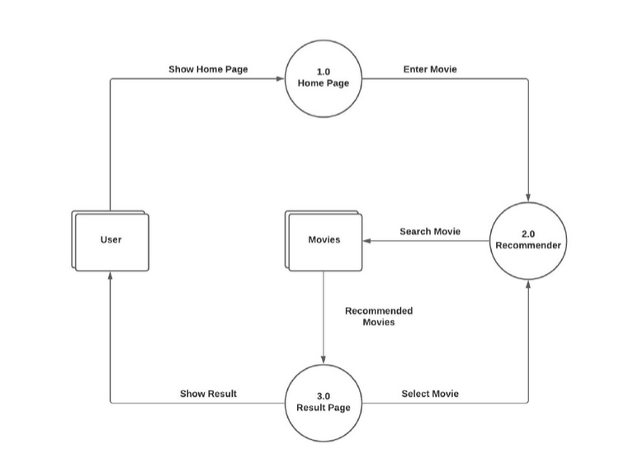

Figure 3.1.6 DFD Diagram Level 1

3.2 **Architectural Design**: The architectural design of Cinematic Compass comprises a presentation layer for user interaction, an application layer for core functionality, and a data layer for storage. Integration facilitates communication with external systems, while security ensures data protection. Scalability and performance optimizations enable seamless operation. Together, these components form a robust and efficient movie recommendation system, catering to user preferences while prioritizing security, reliability, and performance.

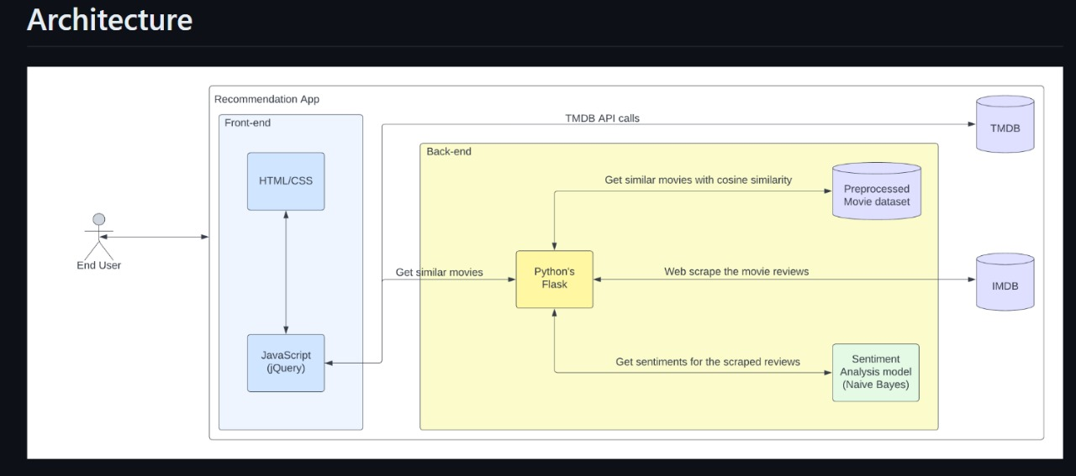

3.3 **Component Design:** The component design of Cinematic Compass emphasizes modularity and reusability to efficiently handle specific functionalities. Key components include the Recommendation Engine, which generates personalized movie suggestions, and the User Profile Management system for user authentication and customization. The Movie Database Interface retrieves movie metadata, while the Recommendation Generation Algorithm implements filtering techniques. User Interface Components ensure a seamless user experience, while the Data Access Layer manages database interactions. Additionally, a Feedback and Rating System allows users to provide input for further refinement. Through modular design, Cinematic Compass maintains flexibility, scalability, and ease of maintenance, ensuring a robust and adaptable movie recommendation system.

3.4 **Database Design:** Cinematic Compass employs a relational database model to store user profiles, movie metadata, ratings, and interaction logs. Tables are normalized to minimize redundancy and ensure data integrity. The database schema includes tables for users, movies, ratings, recommendations, and feedback, facilitating efficient data retrieval and manipulation.

3.5 **User Interface Design**: The user interface of Cinematic Compass prioritizes simplicity, intuitiveness, and aesthetics. It features a clean and visually appealing layout with intuitive navigation and interactive elements. Users can easily search for movies, view recommendations, and manage their profiles. The interface is designed to be responsive and accessible across various devices and screen sizes, ensuring a seamless experience for all users.

3.6 **Algorithm Design: Cinematic** Compass employs a hybrid recommendation algorithm that combines collaborative filtering and content-based filtering techniques. The algorithm analyzes user preferences, movie attributes, and interaction patterns to generate personalized recommendations. It continuously learns and adapts to user feedback, improving recommendation accuracy over time.

3.7 **Error Handling and Resilience Design:** Cinematic Compass implements robust error handling mechanisms to gracefully manage exceptions and failures. It logs errors, alerts administrators, and provides informative error messages to users. The system is designed to be fault-tolerant and resilient, with redundant components and failover mechanisms to ensure uninterrupted service availability.

3.8 **Security Design**: Cinematic Compass prioritizes data security and privacy, implementing encryption, authentication, and authorization mechanisms to protect user data. It follows industry best practices and compliance standards (e.g., GDPR) to safeguard sensitive information. Security measures are enforced at the application, network, and database levels to mitigate security risks and vulnerabilities.

**CHAPTER 4 Implementation and User Interface**

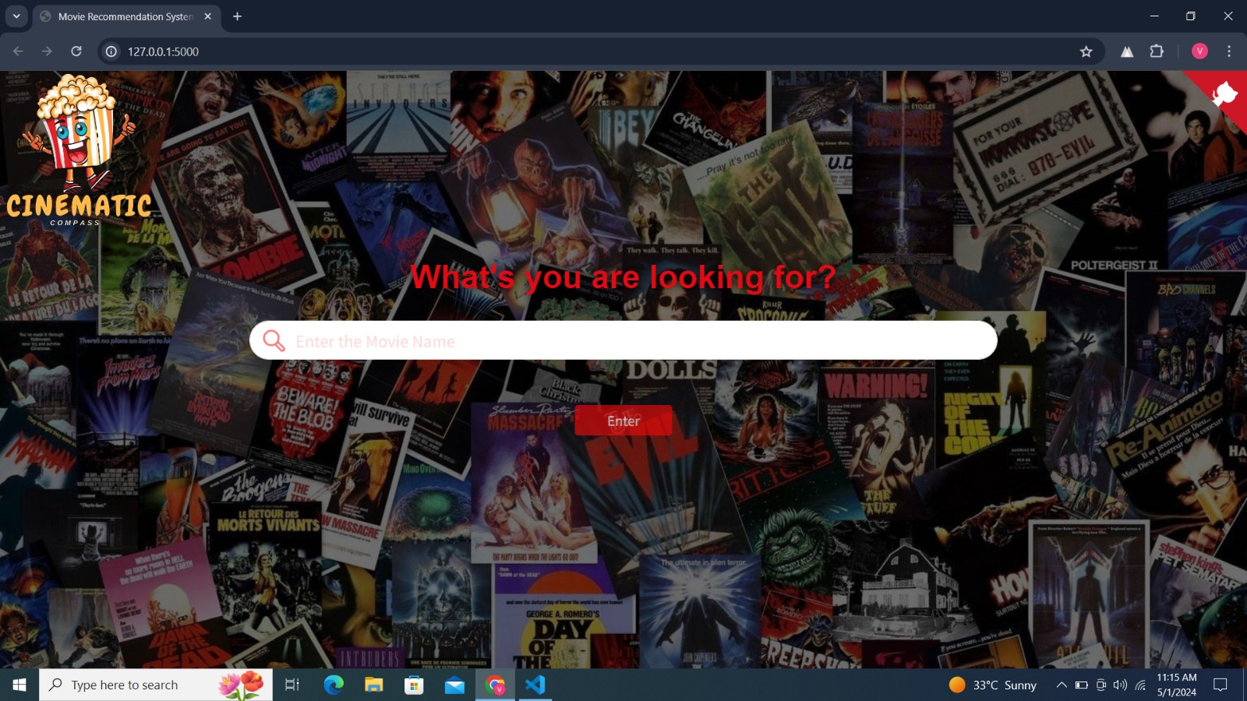

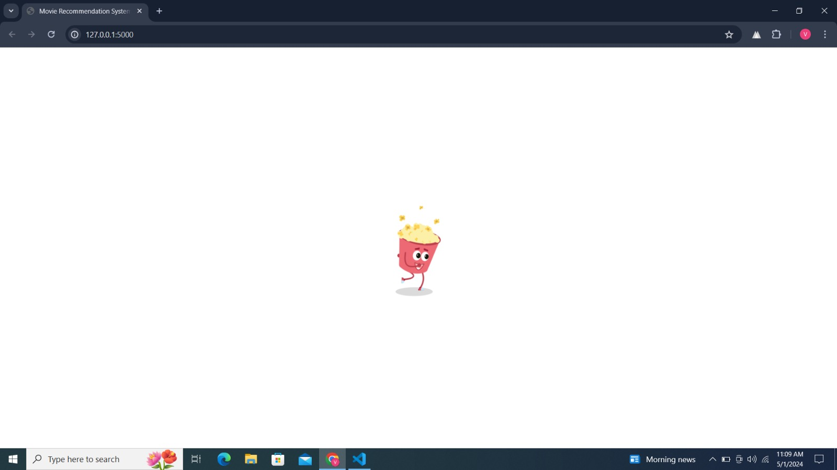

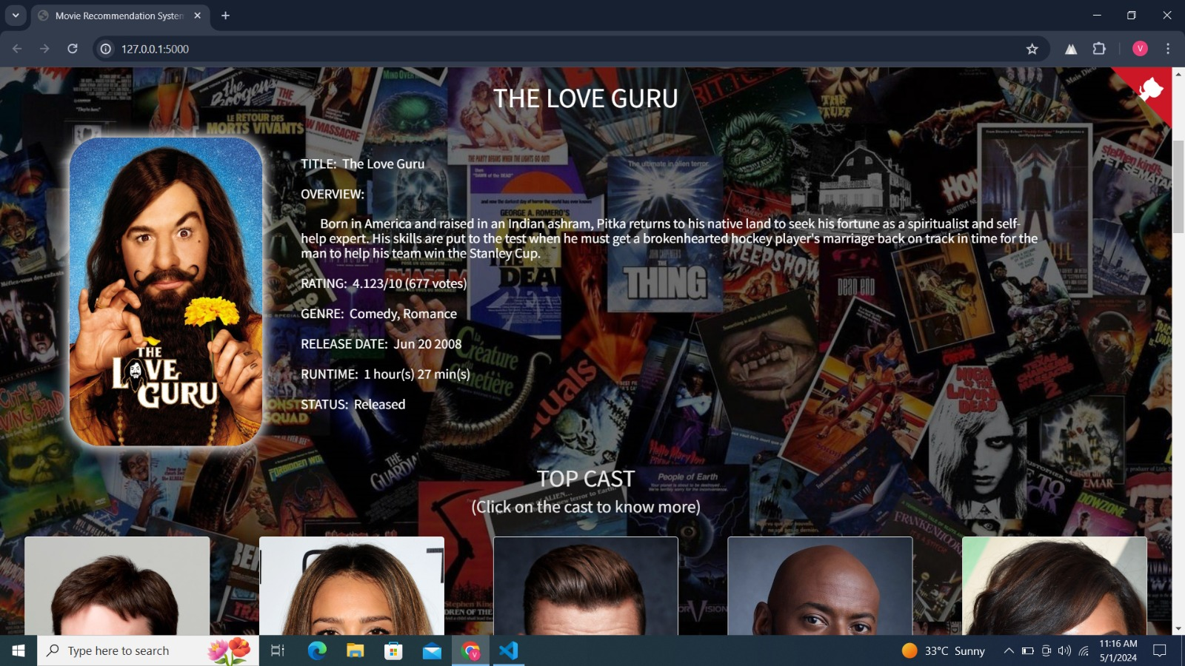

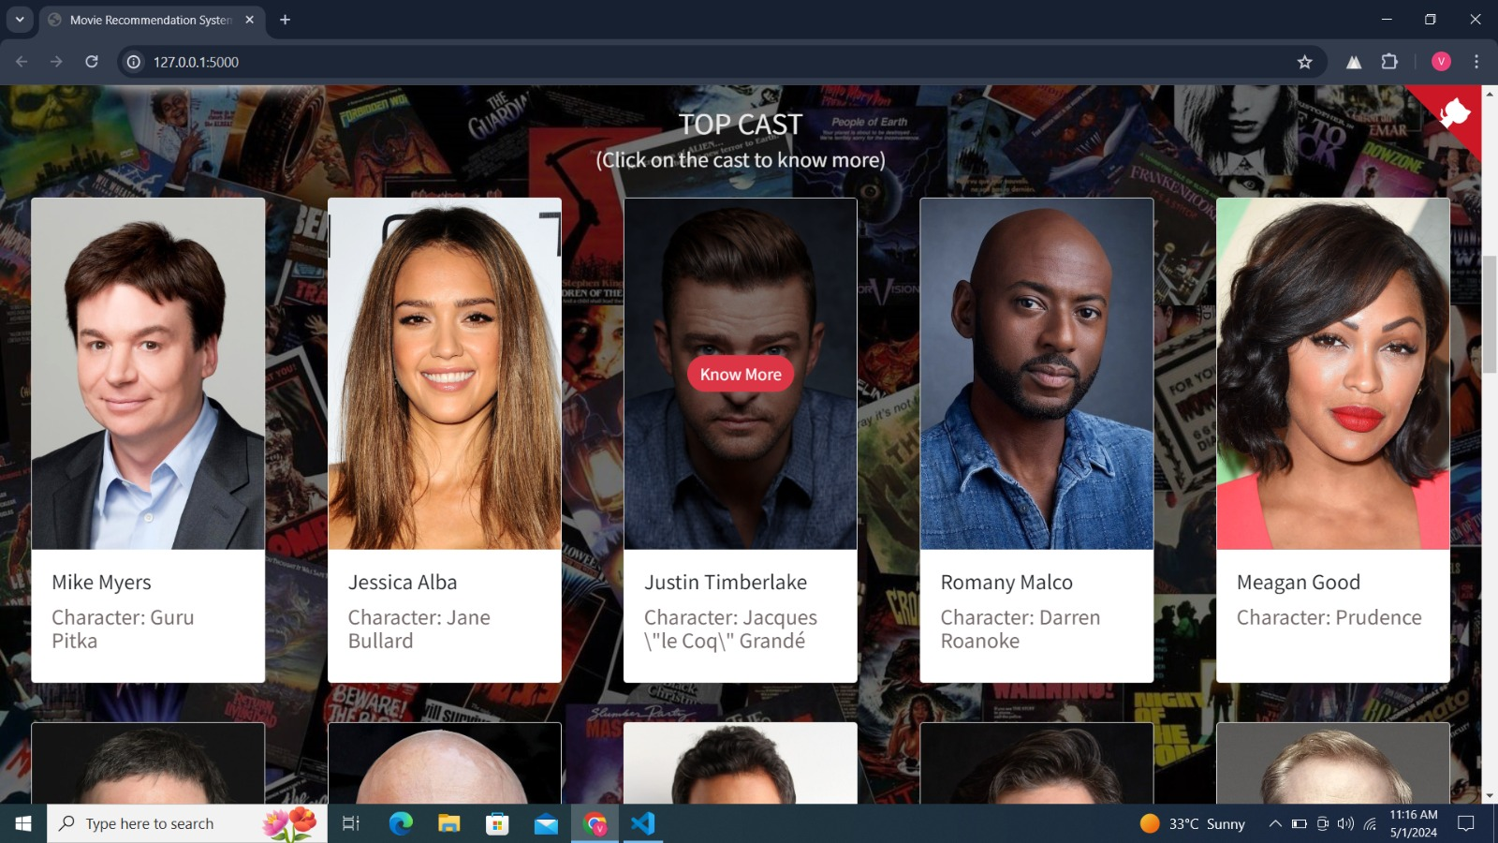



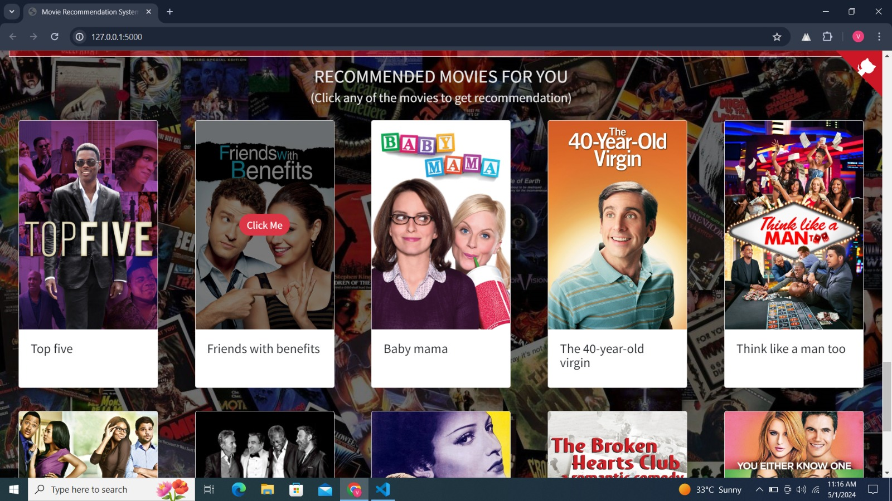

**CHAPTER 5 Software Testing**

5.1 Test Planning:

Test planning for Cinematic Compass is a meticulous process aimed at ensuring the quality and reliability of the system. It begins with a thorough analysis of project requirements, objectives, and constraints to define the scope and objectives of testing. Test strategies are formulated to address various aspects of the system, including functionality, performance, security, and usability. Test scenarios and test cases are meticulously crafted to cover a wide range of use cases and scenarios, ensuring comprehensive test coverage. Test data is carefully selected and prepared to represent realistic and diverse user scenarios, facilitating thorough testing. Resources, including human resources, testing tools, and testing environments, are allocated to execute the test plan effectively. Timelines and milestones are established to track progress and ensure timely completion of testing activities. Throughout the testing process, regular communication and collaboration between stakeholders, including developers, testers, and project managers, facilitate efficient problem resolution and decision-making. Continuous monitoring and evaluation of test results enable adjustments to the test plan as needed, ensuring that testing activities remain aligned with project goals and objectives. Overall, test planning for Cinematic Compass is a structured and systematic process aimed at verifying the quality, functionality, and performance of the system to meet user expectations and requirements.

5.2 Unit Testing:

Unit testing is an essential component of the testing strategy for Cinematic Compass, focusing on validating the individual units or components of the system in isolation. Each unit is tested independently to verify its functionality, behavior, and performance according to specifications. Test cases are designed to cover various scenarios, including normal operation, boundary conditions, and error handling. Testing frameworks and tools, such as JUnit or pytest, are employed to automate unit tests and streamline the testing process. Mock objects and stubs may be utilized to simulate dependencies and isolate units for testing. The goal of unit testing is to identify defects and errors early in the development cycle, enabling prompt resolution and preventing regressions. By ensuring the correctness and reliability of individual units, unit testing contributes to the overall quality and stability of Cinematic Compass, laying the foundation for successful integration and system testing phases.

5.3 Integration Testing:

Integration testing for Cinematic Compass is a critical phase in the testing process, focusing on validating the interactions and interfaces between different components or modules of the system. The objective is to ensure that integrated unit’s function correctly together and communicate effectively, without any compatibility issues or regressions. Integration tests are designed to verify data flows, input/output interactions, and behaviour across integrated components. Various integration scenarios are tested, including positive and negative test cases, to assess system functionality under different conditions. Stubbing or mocking techniques may be employed to simulate external dependencies and isolate components for testing. The integration testing process involves executing test cases, analysing results, and identifying any defects or inconsistencies. Continuous integration (CI) practices are employed to automate integration testing and streamline the testing process, ensuring rapid feedback and early detection of issues. By validating the integration of different system components, integration testing helps mitigate risks associated with system integration and ensures the stability and reliability of Cinematic Compass.

5.4 System Testing:

System testing is a comprehensive phase in the testing lifecycle of Cinematic Compass, focusing on validating the end-to-end functionality, behaviour, and performance of the entire system. The goal is to verify that the system meets specified requirements, operates as intended, and delivers the expected user experience. System tests encompass a wide range of test scenarios and use cases, covering various aspects such as user workflows, business processes, and system interactions. Functional testing validates core system functionalities, while non-functional testing evaluates performance, scalability, security, and usability aspects. Test cases are executed in a controlled environment that closely resembles the production environment to simulate real-world conditions accurately. Automated testing tools and frameworks are utilized to streamline test execution and analysis, enabling efficient identification and resolution of defects. The system testing process involves rigorous validation of system requirements, user acceptance criteria, and quality standards, ensuring that Cinematic Compass meets user expectations and delivers a high-quality movie recommendation experience.

5.5 User Acceptance Testing (UAT):

User Acceptance Testing (UAT) plays a pivotal role in the testing phase of Cinematic Compass, serving as the final validation step before the system is deployed for production use. UAT involves real users or stakeholders interacting with the system to assess its compliance with business requirements, user expectations, and usability criteria. Test scenarios are designed to cover typical user workflows, use cases, and scenarios, allowing users to evaluate the system's functionality and performance in a real-world context. Participants provide feedback, report any issues or inconsistencies, and validate that Cinematic Compass meets their needs and expectations. UAT also helps identify usability issues, user interface enhancements, and workflow optimizations that may improve the overall user experience. By involving stakeholders in the testing process, UAT ensures that Cinematic Compass aligns with business objectives and delivers value to its intended users. Successful completion of UAT indicates that Cinematic Compass is ready for deployment, providing confidence to stakeholders and users alike in the system's reliability, functionality, and usability.

5.6 Performance Testing:

Performance testing is crucial for evaluating the scalability, responsiveness, and reliability of Cinematic Compass under various load conditions and usage scenarios. The objective is to assess how the system performs under normal and peak load conditions, identify performance bottlenecks, and ensure optimal system performance. Performance tests are designed to measure key performance metrics such as response times, throughput, and resource utilization across different components of the system. Stress testing evaluates system behaviour under high loads, while load testing assesses performance under sustained usage. Scalability testing validates the system's ability to handle increasing user loads and data volumes without degradation in performance. Performance testing is conducted using realistic test scenarios and data sets in an environment that closely resembles the production environment. Results are analysed to identify performance issues, optimize system configurations, and improve overall system performance. By conducting performance testing, Cinematic Compass can ensure that it delivers a seamless and responsive user experience, even under demanding conditions, thereby enhancing user satisfaction and retention.

5.7 Security Testing:

Security testing is an essential component of the testing strategy for Cinematic Compass, focusing on identifying vulnerabilities and ensuring the confidentiality, integrity, and availability of user data and system resources. The objective of security testing is to assess the robustness of the system against various security threats and attacks, including unauthorized access, data breaches, injection attacks, and denial-of-service (DoS) attacks. Security tests encompass a wide range of techniques and methodologies, including penetration testing, vulnerability scanning, code analysis, and security audits. These tests evaluate the effectiveness of security controls and mechanisms implemented in Cinematic Compass, such as authentication, authorization, encryption, input validation, and session management. Security testing is conducted at multiple layers of the system, including the application layer, network layer, and database layer, to ensure comprehensive coverage. Results from security testing are analysed to identify potential risks and vulnerabilities, prioritize remediation efforts, and enhance the overall security posture of Cinematic Compass. By proactively addressing security concerns through rigorous testing, Cinematic Compass can mitigate security risks and protect user data, ensuring a secure and trustworthy movie recommendation experience for its users.

5.8 Usability Testing:

Usability testing is a critical aspect of the testing process for Cinematic Compass, focusing on evaluating the ease of use, intuitiveness, and effectiveness of the user interface from the perspective of end users. The objective of usability testing is to identify usability issues, user experience challenges, and areas for improvement to enhance the overall usability and user satisfaction of Cinematic Compass. Usability tests involve real users interacting with the system, performing typical tasks and scenarios, and providing feedback on their experience. Test participants represent the target audience of Cinematic Compass and may include individuals with diverse backgrounds, skills, and levels of familiarity with the system. Usability tests cover various aspects of the user interface, including navigation, layout, labelling, content organization, and interaction design. Usability metrics such as task completion time, error rates, and user satisfaction ratings are collected and analyzed to assess the usability of Cinematic Compass objectively. Results from usability testing are used to identify usability issues, prioritize usability enhancements, and inform design decisions to optimize the user experience. By conducting usability testing, Cinematic Compass can ensure that its user interface is intuitive, efficient, and user-friendly, thereby enhancing user engagement and retention.

5.9 Regression testing:

Regression testing is a critical component of the testing process for Cinematic Compass, ensuring that recent code changes or modifications do not adversely affect the existing functionality of the system. The objective of regression testing is to detect and prevent regressions, which are unintended side effects or defects introduced as a result of code changes. It involves re-executing previously executed test cases to verify that existing functionalities still perform as expected after code changes. Regression tests cover a wide range of scenarios, including functional, integration, and system-level tests, to ensure comprehensive test coverage. Automated testing tools and frameworks are often used to streamline regression testing and facilitate the rapid execution of test cases. Test suites are organized and prioritized based on the criticality and impact of the changes, with high-risk areas receiving more attention during regression testing. Regression test results are analyzed to identify any failures or deviations from expected behavior, which are then investigated and addressed promptly. By conducting regression testing regularly throughout the development lifecycle, Cinematic Compass can maintain the stability, reliability, and quality of the system, ensuring that users continue to receive a consistent and satisfactory movie recommendation experience with each update or release.

**CHAPTER 6 Conclusion**

In conclusion, Cinematic Compass represents a groundbreaking advancement in the realm of movie recommendation systems, offering users a personalized and immersive movie-watching experience like never before. Throughout this journey, we have explored the various facets of Cinematic Compass, from its inception to its architectural design, testing strategies, and beyond. Let us reflect on the key highlights and accomplishments of this innovative platform.

From the outset, the motivation behind Cinematic Compass was clear: to address the growing challenge of content discovery in today's digital age. With an abundance of movies available across various streaming platforms, users often find themselves overwhelmed by choice, struggling to find movies that align with their preferences and tastes. Cinematic Compass was conceived as a solution to this problem, leveraging advanced recommendation algorithms and user-centric design principles to deliver personalized movie recommendations tailored to each user's unique preferences.

The architectural design of Cinematic Compass embodies a modular and scalable approach, ensuring flexibility, reliability, and performance. By breaking down the system into discrete components and layers, Cinematic Compass achieves seamless integration, efficient data management, and robust functionality. From the presentation layer, where users interact with the system, to the data layer, where user profiles and movie metadata are stored, each component plays a crucial role in delivering a seamless and immersive movie recommendation experience.

Testing planning and execution are paramount in ensuring the quality and reliability of Cinematic Compass. From unit testing to system testing, each phase of the testing lifecycle is meticulously planned and executed to validate functionality, performance, security, and usability. Test automation, continuous integration, and stakeholder involvement are key enablers in streamlining the testing process and identifying defects early in the development cycle.

User acceptance testing (UAT) serves as the final validation step, ensuring that Cinematic Compass meets user expectations and delivers value to its intended audience. Real users and stakeholders interact with the system, providing feedback and validation that the system meets their needs and requirements. Performance testing and security testing further validate the system's scalability, responsiveness, and resilience against security threats, ensuring a seamless and secure user experience. In conclusion, Cinematic Compass stands as a testament to the power of technology in enhancing the way we discover, experience, and enjoy movies. With its innovative features, user-centric design, and robust architecture, Cinematic Compass redefines the movie recommendation experience, empowering users to explore a world of cinematic delights tailored to their individual tastes and preferences. As we look ahead, the journey of Cinematic Compass continues, with endless possibilities for innovation, growth, and impact in the realm of movie recommendation systems.

**CHAPTER 7 Summary**

In this chapter, we reflect on the journey of Cinematic Compass, summarizing the key findings, achievements, and insights gained throughout the development and deployment of this innovative movie recommendation system.

We began by exploring the motivation behind Cinematic Compass, identifying the growing challenge of content discovery in today's digital landscape and the need for personalized and immersive movie recommendation experiences. Recognizing this need, we embarked on a journey to design and develop Cinematic Compass, leveraging advanced technologies and user-centric design principles to redefine the way users discover and enjoy movies.

Throughout the development process, we focused on several key areas, including architectural design, testing strategies, and deployment considerations. The architectural design of Cinematic Compass was meticulously crafted to ensure scalability, reliability, and performance, with modular components and layers working together seamlessly to deliver a robust movie recommendation system.

Testing planning and execution played a critical role in ensuring the quality and reliability of Cinematic Compass. From unit testing to system testing, each phase of the testing lifecycle was meticulously planned and executed to validate functionality, performance, security, and usability. User acceptance testing served as the final validation step, ensuring that Cinematic Compass met user expectations and delivered value to its intended audience.

Performance testing and security testing further validated the system's scalability, responsiveness, and resilience against security threats, ensuring a seamless and secure user experience. Deployment and infrastructure design facilitated a seamless and scalable deployment process, enabling rapid updates and enhancements to Cinematic Compass.

In conclusion, Cinematic Compass represents a groundbreaking advancement in the realm of movie recommendation systems, offering users personalized and immersive movie-watching experiences like never before. As we look ahead, the journey of Cinematic Compass continues, with endless possibilities for innovation, growth, and impact in the realm of content discovery and consumption. With its innovative features, user-centric design, and robust architecture, Cinematic Compass is poised to shape the future of movie recommendation systems for years to come.

**APPENDICES**

**Appendix: Sample References**

1. J. Bobadilla, F. Ortega, A. Hernando, and A. Gutiérrez, "Recommender systems survey," Knowledge-Based Systems, vol. 46, pp. 109-132, 2013.
2. R. S. Abbas, M. M. Hasan, and M. A. Hossain, "Movie recommendation system using collaborative filtering algorithm," in 2016 International Conference on Electrical, Computer and Communication Engineering (ECCE), pp. 445-448, 2016.
3. L. Zeng, L. He, and H. Liu, "An improved movie recommendation system based on collaborative filtering algorithm," in 2018 IEEE 2nd Advanced Information Management, Communicates, Electronic and Automation Control Conference (IMCEC), pp. 1602-1605, 2018.
4. S. Agarwal and S. T. Kumar, "A hybrid recommendation system for movie recommendation," in 2018 10th International Conference on Computational Intelligence and Communication Networks (CICN), pp. 97-101, 2018.
5. S. Bansal and N. K. Jain, "Content-based movie recommendation system using machine learning," in 2018 International Conference on Computing, Power and Communication Technologies (GUCON), pp. 176-179, 2018.
6. V. Thakur, V. Rastogi, and S. Sinha, "Movie recommendation system using deep learning," in 2019 3rd International Conference on Trends in Electronics and Informatics (ICOEI), pp. 331-334, 2019.
7. R. K. Sharma, S. Thakur, and A. Verma, "A novel approach for movie recommendation using machine learning," in 2019 3rd International Conference on Intelligent Computing and Control Systems (ICICCS), pp. 693-698, 2019.
8. S. Das, A. K. Das, and B. Gupta, "An efficient recommendation system for movie domain using machine learning techniques," in 2019 6th International Conference on Signal Processing and Integrated Networks (SPIN), pp. 234-238, 2019.
9. Y. Zhou, J. Sun, and J. Yan, "An intelligent movie recommendation system based on improved collaborative filtering algorithm," in 2020 IEEE International Conference on Big Data and Smart Computing (Big Comp), pp. 1-6, 2020.
10. K. Kumar, R. Kumar, and S. Bhattacharya, "A comprehensive review on movie recommendation systems," in 2020 International Conference on Emerging Trends in Expert Applications & Security (ICETEAS), pp. 1-5, 2020.